

****PRESS RELEASE****

FOR IMMEDIATE RELEASE

CABLE & SATELLITE LOW COST SOLUTION

QFX USA, INC. – VERNON, CA
October 19, 2016
AFFORDABLE 1080P HD TV WITH NO CABLE COSTS!
As we all know the only way to view a full 1080P HD ATSC TV signals is from on air TV broadcast stations, cable TV at best can only deliver a 720P signal.
QFX has joined fight against the high cost of cable TV service and is very pleased to announce the introduction of three new HD Antenna that can provide solutions for consumers that are fed up with paying for the high cost of cable or dish TV systems.
The ANT-8 and ANT-17 flat panel HD antennas are designed to provide a superior for TV viewers located in cities or nearby suburbs. The ANT-17 is so thin it can be please almost anywhere in a home without being noticed. The long range all weather ANT-111 (shown below) receives HD transmissions from over 46 miles away to produce outstanding HD images for homes out in the countryside suburbs. The ANT-8 has a SRP of $18.99; the ANT-17 SRP is $19.99, and the long range ANT-111 has a very affordable SRP of $39.99. All three models are in stock and available for immediate shipment.

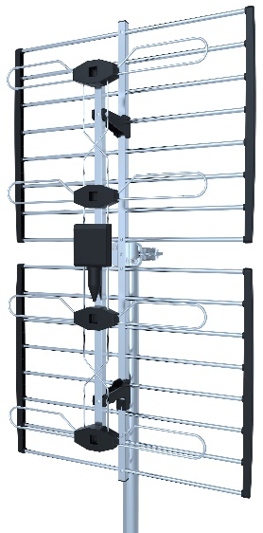ANT-111

